NDIS Provider and Worker Registration Taskforce

Department of Social Services

A joint submission from Disability Representative Organisations

**1 May 2024**

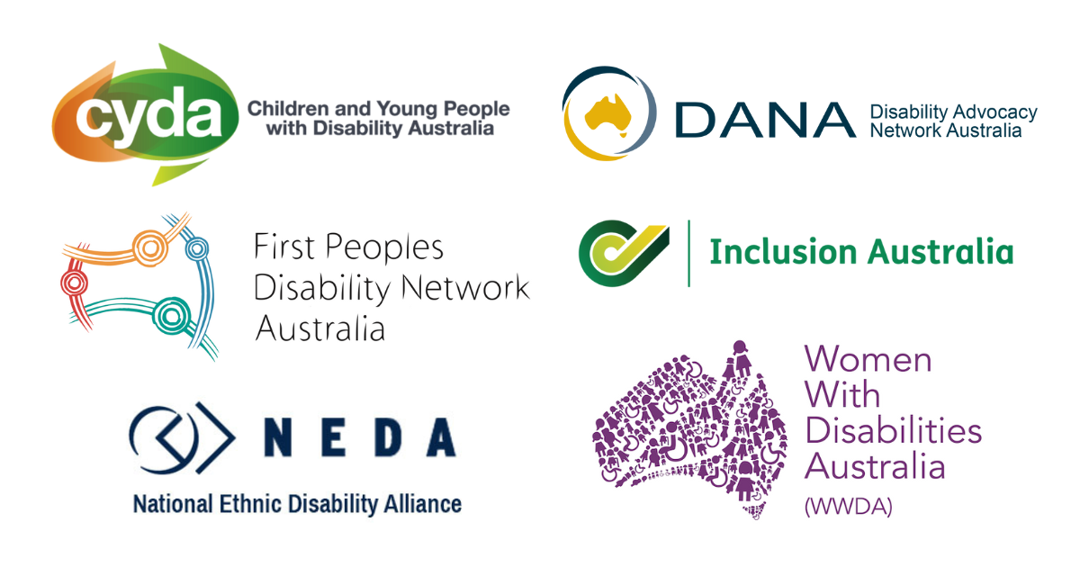

Table of Contents

About Us 2

Introduction 3

Recommendations 4

Quality and safety 5

Choice and control 7

Leadership and codesign 9

# About Us

Disability Representative Organisations are funded by the Department of Social Services (DSS) to represent people with disability. The following organisations have endorsed this joint submission:

* Children and Young People with Disability Australia
* First Peoples Disability Network Australia
* Disability Advocacy Network Australia
* Inclusion Australia
* National Ethnic Disability Alliance
* Women with Disabilities Australia

This submission was prepared by Disability Advocacy Network Australia, in their role as the National Coordination Function for the Disability Representative Organisations program.

# Introduction

Many of the national Disability Representative Organisations (DROs) have come together to make key recommendations to the NDIS Provider and Worker Registration Taskforce (the Taskforce). These recommendations are designed to guide the Taskforce’s expert advice to the Government about the proposed graduated risk-proportionate regulatory model and implementation of new regulatory arrangements, including the Provider Risk Framework.

The NDIS Review (the Review) has flagged key reasons for the need for change, many of which centre on the need to improve the quality and safety of services and prevent harm to people with disability. The current registration system is not fit for purpose, does not stop violence and abuse of people with disability, does not prevent conflicts of interest or provider exploitation of people with disability. The system does not encourage high quality and innovative services and supports for people with disability.

With the introduction of a new regulatory framework, there are key principles that must be central to the reform process. The following key principles should guide the next steps about registration:

1. People with disability must have choice and control over the supports they use, both inside and outside the NDIS – for example, people with disability can use mainstream services, and purchase consumables from mainstream outlets.
2. People with disability need to have safer and higher quality services and supports.
3. People with disability need to be involved in co-design of a new registration and quality system.
4. People with disability who need support for decision making need to be consulted about the supports they use, with independent support for that decision making.
5. People with disability need to have access to capacity building information and support to engage with services and supports – for example, independent, accessible, peer led information and support to build skills and knowledge about what is a good quality service.
6. An individualised evidence-based risk assessment framework is developed with people with disability, including changes to the safeguards mechanism to enable this.
7. Issues for people with disability who live in regional, rural and remote areas are considered.

Our recommendations reflect these key principles and are structured around the essential elements required in the development and implementation of changes to provider and worker registration:

* Improving safety and quality of services and supports for people with disability.
* Preserving and improving choice and control for people with disability.
* Embedding codesign and meaningful consultation with people with disability.

# Recommendations

**Recommendation 1:** That the registration system ensures that people with disability have safer and higher quality services and supports.

**Recommendation 2:** That people with disability have access to capacity building information and support to engage with services and supports.

**Recommendation 3:** That the new registration and quality system ensures that people with disability have choice and control over the supports they use, both inside and outside the NDIS.

**Recommendation 4:** That issues for people with disability who live in regional, rural and remote areas are considered in the development of the new registration and quality system.

**Recommendation 5:** That people with disability lead and are central to co-design of a new registration and quality system.

**Recommendation 6:** That people with disability who need support for decision making are consulted about the supports they use, with independent support for that decision making.

**Recommendation 7:** That an individualised evidence-based risk assessment framework is developed with people with disability, including changes to the safeguards mechanism to enable this.

# Quality and safety

The Review flagged improving quality and safety as a key reason for the need for changing the current system of registration, including:

* Lack of visibility of payments to unregistered providers.
* Reliance on individuals to assess risk and quality.
* Quality and Safeguards Commission cannot monitor market or take regulatory action.
* Need for oversight of unregistered providers, particularly those providing home and living supports.
* Current worker screening not working well to provide quality services and safety.
* Quality and Safeguards Commission not effectively addressing ‘conflicts of interest and client capture, sharp practices (including unfair service agreements), transparency and duties of care.’

The Review discusses an individualising of risk assessment and a wide range of safeguarding measures, both existing and new.

There is significant uncertainty around how the design of a new system will address the significant safeguarding gaps that exist for both registered and unregistered providers. People with disability are currently being harmed due to the practices of unregistered and registered providers. There are particular risks and experiences for people with disability who use 24/7 support in a variety of settings and systems, particularly those that are closed to the community.

Reform to the NDIS Quality and Safeguards Commission is essential to deliver substantial change to rates of violence and abuse against people with disability. If safety and quality is not embedded in the design of a new regulatory framework, it will fail to achieve the most important objectives of reform. Mechanisms to ensure scrutiny, with an emphasis on improving safety and quality, must be central throughout the reform and implementation process.

Any changes must incorporate increasing the capacity of the current Quality and Safeguards Commission to manage the large increase in registrations, and to oversee compliance, as well as proactively preventing abuse and handling complaints. Changes also need to provide the ability for the Quality and Safeguards Commission’s to adequately deal with ‘conflicts of interest and client capture, sharp practices (including unfair service agreements), transparency and duties of care.’

The recommendations from the Disability Royal Commission (Volume 10, Part B: NDIS Quality and Safeguards Commission) and the NDIS Review (Recommendation 19) both discuss the need for major safeguarding reform, and DROs believe this is urgent. The operations and structure of the NDIS Quality and Safeguards Commission need to be addressed as a vital part of any changes to the registration system.

There needs to be accessible, peer led information and support to build skills and knowledge about what is a safe and quality service, for example, independent, accessible, peer led information and support to build skills and knowledge about what is a good quality service.

**Recommendation 1: That the registration system ensures that people with disability have safer and higher quality services and supports.**

**Recommendation 2: That people with disability have access to capacity building information and support to engage with services and supports.**

# Choice and control

The NDIS Review’s proposed overhaul of the provider and worker registration system has caused significant anxiety and concern within the disability community. The major change is that, under a new graduated risk-proportionate regulatory model, all NDIS providers would be enrolled or registered. Under the current system, supports are provided by registered or unregistered providers, and most types of support can be provided by unregistered providers.

The large growth in unregistered providers has allowed people with disability to have more choice and control over their NDIS supports, but also has enabled significant predatory market behaviour from new and existing providers. Some people with disability and organisations strongly support the proposed Enrolment system, but for others, there are concerns about some elements and the potential impact on choice and control of people with disability to choose what providers we use.

There is significant distress around the impacts of requiring all providers to be registered. In particular, the effects on:

* self-management, including directly employing support workers; and
* accessing mainstream services, for example for purchasing of consumables.

The risk of deterring providers from providing NDIS funded services, and thereby decreasing the number of services is particularly concerning for groups already facing lack of availability of supports. There is also anxiety about registration compliance costs being transferred to people with disability, and consequences on the affordability of supports. It is vitally important that the implementation process must not interfere in the continuity of supports for people with disability.

As discussed in the previous section, there is a clear need for the system to better protect people with disability from harm and increase quality of supports. Any changes need to carefully consider how they can preserve, and improve, choice and control for all people with disability to effect better outcomes. This underscores the need for people with disability to lead the development and implementation, including careful and deliberative co-design at every stage of the reform process.

People with disability are particularly concerned that a new system must avoid unintended negative effects on the availability and cost of supports in regional, rural and remote communities:

* People with disability who live in regional, rural and remote communities already face profound challenges with access and cost effectiveness of supports;
* Many locations currently have no or a very small number of registered providers, or providers that provide a small proportion of NDIS supports compared with other services;
* People with disability fear the proposed changes disincentivise local providers from providing supports to NDIS participants, and increase the challenges faced by people with disability in regional, rural and remote communities.

Groups most impacted by availability and accessibility of services and supports need to be central in codesign. People with disability who live in regional, rural and remote Australia need to be included in the consultation and codesign through resourced engagement with representative, advocacy and peer support organisations and networks operating in these local communities.

The ability to exercise choice and control of providers is particularly important for intersectional communities of people with disability both inside and outside the NDIS. The impacts on First Nations, Culturally and Linguistically Diverse (CALD), LGBTQIA+SB, and other diverse communities need to be examined and considered carefully throughout the NDIS reform process. These communities face additional and unique barriers to accessing safe and quality supports.

**Recommendation 3: That the new registration and quality system ensures that people with disability have choice and control over the supports they use, both inside and outside the NDIS.**

**Recommendation 4: That issues for people with disability who live in regional, rural and remote areas are considered in the development of the new registration and quality system.**

# Leadership and codesign

People with disability must lead the design and implementation of reforms to the system. Any change of this magnitude needs to be done in concert with the disability community, including via our representative organisations. This includes:

* Leadership by people with disability and their representative organisations;
* Meaningful codesign and consultation with the disability community, including transparent engagement plans and timelines;
* Consultation with those most impacted by the changes, including People with disability who live in regional, rural and remote;
* Specific consultation with First Nations, Culturally and Linguistically Diverse (CALD), LGBTQIA+SB, and other diverse communities; and
* Adequate resourcing and time to properly consult with our communities and respond.

We have repeatedly raised the need for meaningful leadership and codesign in our responses to both the NDIS Review and Disability Royal Commission. Our organisations have called for the establishment of a Disability Reform Implementation Council, led by people with disability and our organisations, to oversee the changes flowing from the Disability Royal Commission and the NDIS Review. We have proposed that the Council report directly to National Cabinet and have working groups specialising in key reform areas, which would include changes to NDIS provider and worker registration.

The Council must have people with disability, our families and organisations at the table to share in decision-making, with working groups to address issues for different communities of people with disability. It would be a particular focus on ensuring the work of the Council is underpinned by the priority reforms of the National Agreement of Closing the Gap, already agreed to by all governments, in recognition of the continued marginalisation of First Nations people with disability.

This proposal is in line with Australia’s Disability Strategy. Other significant reforms, such as the National Agreement on Closing the Gap and the response to the Aged Care Royal Commission, have recognised the need to engage with and resource the communities affected to share in decision making about priorities.

Our organisations need sufficient time and resourcing to engage with people with disability about these reforms. To manage the large increase in workload for DROs, including to engage fully with people with disability and our families and supporters, our organisations need a significant uplift in resources. DROs needs additional resources in order to engage staff, develop consultation mechanisms and deliver on this complex, cross-government liaison and co-design.

Consultation and codesign must centre people with disability from intersectional communities through resourced engagement with representative, advocacy and peer support organisations and networks operating in these local communities. This includes people who live in regional, rural and remote Australia, First Nations, Culturally and Linguistically Diverse (CALD); and LGBTQIA+SB.

Many of our organisations work with significantly marginalised people with disability, including from population groups that have many barriers to having their voices heard. Our organisations need the capacity to engage with people with disability, particularly those with significant barriers to having their voices heard, including the sustainability of staff and organisations to contribute to the engagement and consultation process.

The process of designing a new system needs be inclusive and accessible for all people with disability. People with disability who need support for decision making must be involved and be given the independent support they need in the process.

The Taskforce has been established to provide expert advice on a Provider Risk Framework that identifies and evaluates the risk profile of different types of supports and providers. This includes clarifying new arrangements for platform providers and circumstances where participants directly employ their workers, including ‘Services for One’ where participants and their families may directly employ workers to deliver supports.

The development of this framework must be led by people with disability, and enable our community adequate time and resources to work through complex issues, including improved safety and quality and preserved choice and control. We are the people who have experience of violence, abuse, neglect and exploitation, and have to be at the forefront of measures to stop this happening to us.

Implementation of reforms from the NDIS Review can only be effective in stopping the violence so many of us live through if we are leading that implementation. Our communities must be involved in both designing and testing improvements to provider and worker registration to ensure they work well for everyone.

**Recommendation 5: That people with disability lead and are central to co-design of a new registration and quality system.**

**Recommendation 6: That people with disability who need support for decision making are consulted about the supports they use, with independent support for that decision making.**

**Recommendation 7: That an individualised evidence-based risk assessment framework is developed with people with disability, including changes to the safeguards mechanism to enable this.**