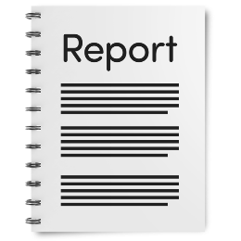Priorities Project Report - Executive Summary

A report is a paper that is written about something like a project, it says the things that were learned.

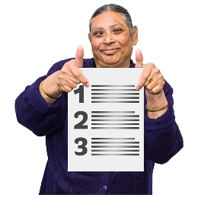Priorities means the most important things. When we say priorities in this paper, we mean the important things that need to be done.

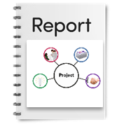An Executive Summary is a paper that says the most important things from a big report.

In this paper we will call the Priorities project the project.

About the Priorities Project

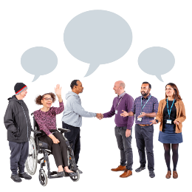The project is a way for people with disability to tell the Federal Government:

* what the disability community wants made better
* 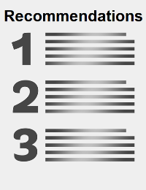ideas about how things can be fixed.

The ideas talked about in this report are called recommendations.

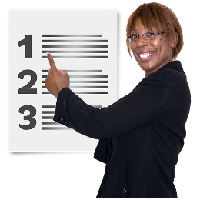The recommendations are the things that should be done:

* over the next 1-2 years
* to make change happen for people with disability.

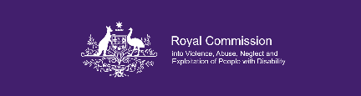The Disability Royal Commission and the NDIS Review made 248 recommendations.

A review is a way to look at something to learn more about it.

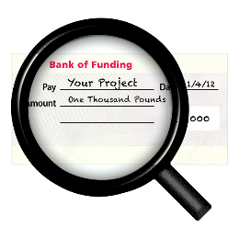When we say we in this paper we mean the people who wrote this report.

The Project was paid for by a group that fund projects in the community.

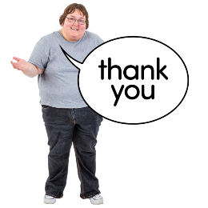We say thank you to the group who paid for us to do this work. This work helps make change for people with disability.

How we did the Project

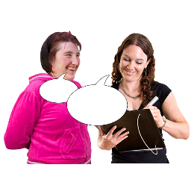We asked people their ideas about:

* the Disability Royal Commission
* NDIS Review recommendations
* the most important things that need to change
* how to make the changes.

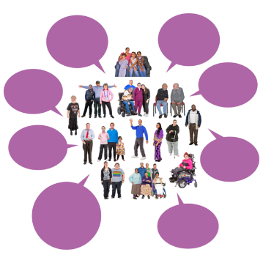The people we asked were from:

* disability groups, these are groups who speak up for people with disability
* disability Advocacy Network Australia (DANA)
* disability advocates, these are people who speak up for people with disability
* people with disability
* 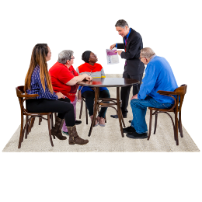people who know a lot about things, like housing for people with disability.

A magnifying glass over a group of people
next to a map of AustraliaTo do this report we had 28 meetings and talked to 130 people.

We did focus groups in each state and territory of Australia.

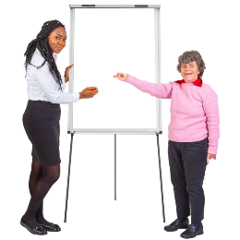One of the important things we talked about, was how to start to make changes.

The information we learned helped us to make the recommendations in this executive summary.

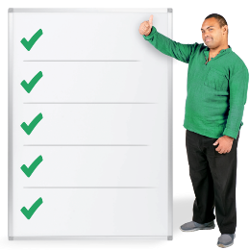The important things we heard

The Disability Royal Commission and the NDIS Review say the same important things that we heard from people.

The six priorities we looked at are:

1. **Who can get disability supports and how?**
2. 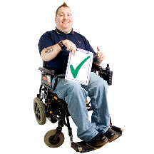**Housing**
3. 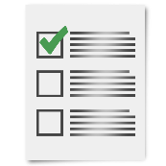**Keeping people safe**
4. 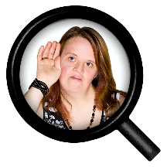**Supports people need first**
5. 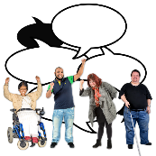**Who we need to hear from**
6. **Advocacy or speaking up for people’s rights**

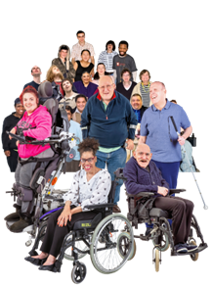To make the changes we will work with:

* people with disability
* disability advocates
* experts, these are people who know a lot about things
* other supporters.

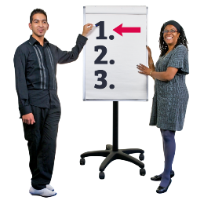We have ways the priorities need to be worked on over the next 1 to 2 years.

These ways will help the Federal Government know what people with disability need, like:

* 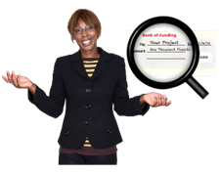test places in the community to see if there are things missing like, money to pay for supports and services
* 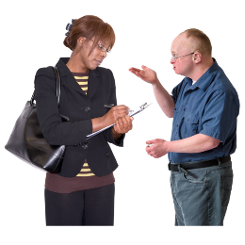ways to make sure people with disability get to have a say about:
* support they need
* how to make changes.

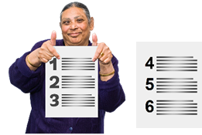Over the next few pages, we will say more about:

* the six priorities
* what the Disability Royal Commission said
* our recommendations.

About the six priorities

**Priority 1:**

**Who can get disability supports and how?**

We know that:

* 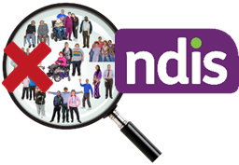not all people who have a disability get funding from the NDIS
* 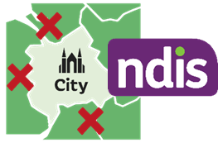there are not many disability supports for people who are not getting funding from the NDIS
* there are not many services for people with disability who live far away from cities and big towns.

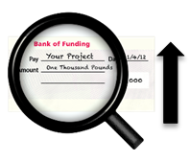These places do not have the same services and supports as the cities.

They need more funding to be able to give people with disability the same support as people who live in or near the cities.

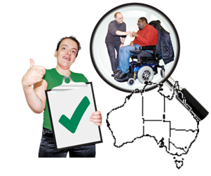What the Disability Royal Commission said about: **Who can get support and how**

* make a ‘provider of last resort’ scheme for all Australian states and territories. The ‘provider of last resort’ scheme will make sure there are always ways for people to get disability supports
* 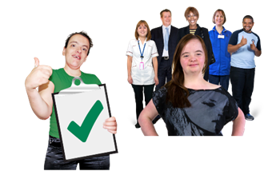make sure there are supports for all people with disability to use the support they need, like:
* community support
* the first supports they need to get
* NDIS supports.

Our Recommendation:

Who can get support and how?

* + - 1. 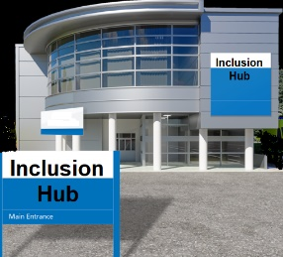Have test places in the Community called Inclusion Hubs for people with disabilityto get:
* support
* information
* 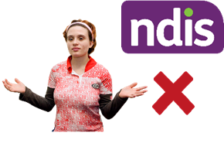connection.

1. Make a way for people with disability to get the things they need to support their disability needs that does not use NDIS money, like:
2. 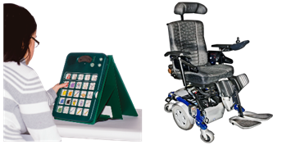aids and equipment, like a wheelchair or hoist

* assistive technology**,** like a screen reader on a computer.

People with disability who are not getting NDIS funding can ask for and get funding to get these supports.

**Priority 2:**

**Housing**

We know that:

* finding and keeping a house is harder for people with disability

This is because:

* the amount of money most people with disability have is not as much as people that do not have disability
* 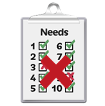there are not as many houses as there needs to be
* 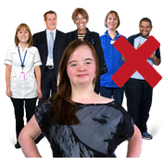people are not able to get the changes made to their house that they need
* if a person has to move out of their house some of their support might stop
* 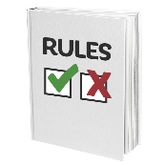people who get NDIS funding can get housing supports, but they need to follow a set of rules
* there is no housing support for people with disability who are not getting NDIS funding.

What the Disability Royal Commission said about: **Housing**

* 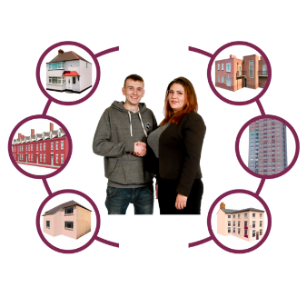group homes should be shut down over time
* have Housing and Living Navigators. These jobs will help people with disability get and have a home
* 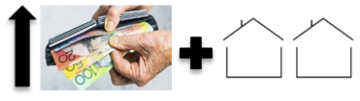make changes to Specialist Disability Accommodation (SDA) like:
* how much it will cost
* having more homes for people with disability.

Our Recommendation:

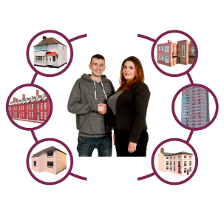**Housing**

Have a way to test a job called a Specialist Housing Navigator.This job will helppeople with disability choose where they can live.

Make a way for people to make changes to their house that is not using NDIS funding.

This will make sure all people with disability can make changes to their house to support their disability needs.

This should also be about knowing the things that stop people from being able to make the changes to their house that they need.

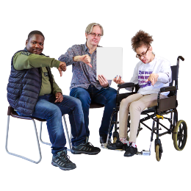

**Priority 3:**

**Keeping people safe**

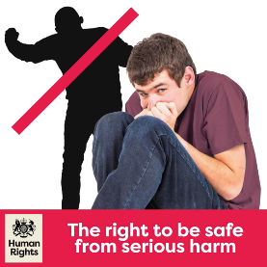We know that:

* the ways people are being kept safe now are not working
* the Disability Royal Commission says places need to be closed like:
* group homes
* 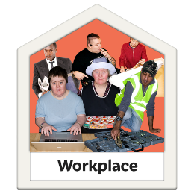special schools
* Australian Disability Enterprises (ADE).

An ADE is an employment service for people with disability who need support to work.

* 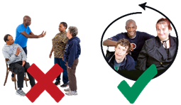People say:
* it is not a good idea to keep people apart from other people
* the community needs to be for everyone
* there needs to be more information for people with disability about how this will be done so they do not get too worried.

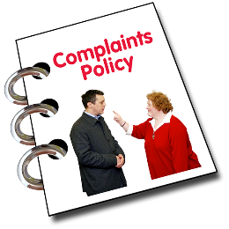What the Disability Royal Commission said about: **Keeping people safe**

* make a complaints process that will support all the complaints
* A group of people looking at a plan
  next to a person greeting someone at their front door with a map of Australia below itmaking a group called the NDIS Review Implementation Working Group. This group will make sure people with disability are included in making changes to have the Community Visitor Scheme in all the states and territories of Australia.

Our Recommendation:

**Safeguarding**

* + - 1. A person holding a magnifying glass and a person taking notes next to two people talkinig

         Test how case management supports work for people with disability.

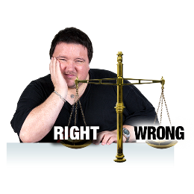Case management is a job that helps people with disability get the supports they need.

The groups this would help are:

* A child standing next to a house outline with a red cross in it
  people who are in the justice system. The justice system is about the laws and rules in the community.
* young people who might have to leave home
* 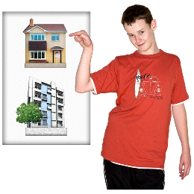transition support is support for people moving out of home
* 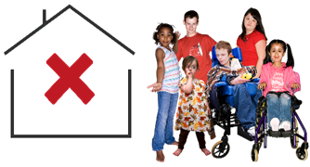family case management
* children in out of home care.

This should link to the recommendations made by the Disability Royal Commission.

**Priority 4:**

**Supports people need first**

We know that:

* A group of people with disability standing next to each other

  with a thought bubble with a person in a wheelchair being supportedthe disability community are worried about:
* foundational supports or the first supports people with disability get
* if these supports will be right for people with disability and the community.

Logo of the Australian government
A young person looking at a magnifying glass
What the Disability Royal Commission said about: **Supports people need first**

There needs to be:

* support from the federal, state and territory governments
* a way to support how people with disability get these first supports.

Our recommendation:

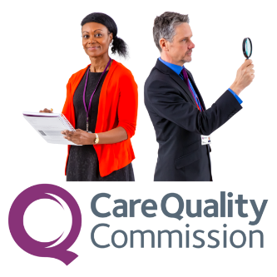**Making a way for people to get the supports they need first**

* + - 1. Make a way to check what supports people with disability:
* 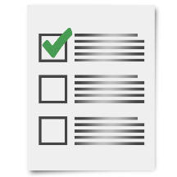need first
* use now and what supports they could need in the future
* a magnifying glass over a cheque next to group of people standing together
  might have to stop using.

1. Put funding in to:

* have peer support workers as one of the first ways to support people.

1. 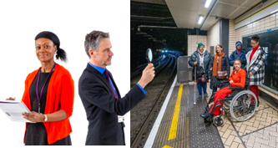Test one of the first supports like community transport for people with disability and very special needs. This will say how to get ready for the things that need to change.

**Priority 5:**

**Who we need to hear from**

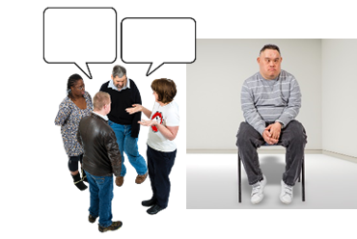We know that the most important people we need to talk to are people who:

* will have changes made in their lives
* are not talked to about the changes

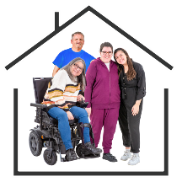These people:

* live in group homes
* live, work, or go to school in closed settings.

A closed setting is a place that is only for people with disability.

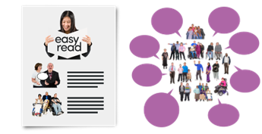When people are asked to give their ideas and feedback, this needs to be accessible and include people.

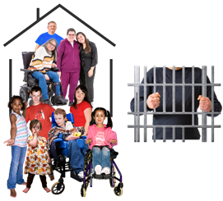These are people who have lived in places like:

* group homes
* boarding houses
* prisons
* out of home care.

What the Disability Royal Commission said about: **Who we need to hear from**

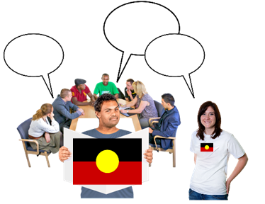We need to hear from:

* First Nations people by making a group called the First Nations Disability Forum
* First Nations disability workers who work in remote communities
* people with disabilities to talk about the changes that the Disability Royal Commission and NDIS Review talked about.

Our recommendation:

A group of people with disability 

**Representation and inclusion**

* + - 1. Set up a group called a Lived Experience Transition Taskforce.

The group will be for:

* people with disability
* people who work with or support people with disability.

The group will be led mostly bypeople with an intellectual disability, who in the past have lived in a place away from other people.

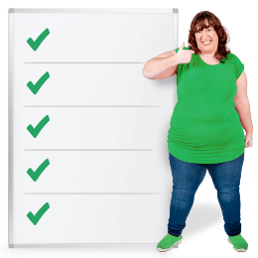These people can help to say what is needed to make sure people are not left out of things in the future.

**Priority 6:**

**Advocacy or speaking up for people’s rights**

We know that:

* Two women standing back to back with crossed arms one with a green tick one with a red cross
  A magnifying glass over the top of a cheque next to a red cross 

  Advocacy is important. Advocacy groups do not get the funding they need to support everyone who is asking for help.

Only one of two people with disability who ask for advocacy support can get it.

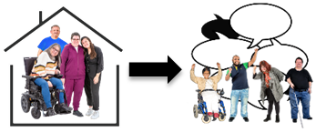What the Disability Royal Commission said about: **Advocacy or speaking up for people’s rights**

* 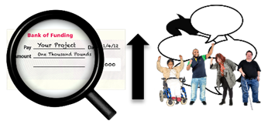make a way for people who live in supported accommodation to link with disability advocacy supports
* more money to pay for disability advocacy services.

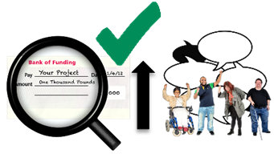Our recommendation:

**Advocacy or speaking up for people’s rights**

1. Support ways to speak up for people’s rights.

* advocacy for people with disability does not get the funding it needs now
* getting advocacy support will get harder when people need information to know about the changes.

**Inclusion Europe Easy to Read logo 
VALID logo and Easy Read contact details 
Photosymbols logo **